Contents

Part 1: Project Introduction 3

**Introduction** 3

**Literature Review** 4

Part 2: Overview of the Methodology 6

**Data collection process and techniques** 7

Part3: Analyzing Customer Sentiment on Flipkart: Insights into Customer Satisfaction 9

**Overview of Data Analysis** 9

**Analyzed conducted:** 9

**Word Frequency** 10

**Sentiment Analysis** 10

**Topic Modeling and Sentiment Label** 10

**Optional Analysis** 11

Part 4: Research Discussion 14

**Discussion** 14

**Practical Recommendation** 17

**Study Limitations and Recommendations for Future Research** 19

**Conclusion** 19

**References** 20

# Part 1: Project Introduction

## **Introduction**

In today’s fast-paced digital marketplace, analyzing consumer sentiment can drive critical insights for business strategy. For this project, our team has chosen to focus on the **E-commerce industry**, exploring customer sentiments about various products sold on Flipkart.com. The dataset includes data on diverse products like electronics, clothing, and home decor, each labeled with sentiment categories (positive, neutral or negative). Given the competitive and varied nature of e-commerce, this analysis will enable us to identify patterns in consumer opinion, helping industry leaders adapt to preferences and needs.

Diving into how the research problem we have stated above impacts businesses, society, the public or customers. Sentiment analysis enables businesses data-driven decisions which helps in adapting to changing market conditions. Sentiment analysis will help businesses improve marketing strategies targeted at improving product offerings. This in turn helps to improve customer retention. From the societal standpoint, sentiment analysis will also affect businesses in the sense that if society responds to a product negatively, it helps businesses focus on what they need to improve on and also if they get widespread positive reviews, it helps them focus more on what they need to continue doing. When it comes to the public or customers, sentiment analysis can impact their reactions to negative or positive reviews on products. Sentiment analysis can impact customer loyalty and retention, where positive reviews build trust which in turn helps make a more informed purchase decision.

The importance of this research lies in its ability to inform e-commerce strategies for targeted marketing, customer service improvements, and product assortment decisions based on sentiment trends. By categorizing and analyzing consumer feedback, businesses can better predict purchasing behavior and improve customer satisfaction.

**Theoretical Contributions**: This study will build on existing sentiment analysis research in e-commerce by introducing new perspectives on stakeholder opinion trends in a multi-category product setting. By comparing sentiment trends across product types, we aim to contribute fresh insights to studies in consumer behavior and marketing analytics.

**Research Objectives**

1. Assess overall sentiment distribution across product categories on Flipkart.com.
2. Identify key themes within positive, neutral, and negative sentiments using topic labeling.
3. Evaluate the correlation between product price, rating, and sentiment.
4. Compare sentiment trends across major product categories to determine customer satisfaction drivers.

**Research Questions**

1. What is the general sentiment distribution across different product categories?
2. Which topics or themes emerge within each sentiment category?
3. How do price and ratings influence customer sentiment?
4. Which product categories reflect the highest and lowest customer satisfaction?

**Structure of the Research Project**

The report will be organized as follows:

1. **Introduction**: Provides background, importance, objectives, and structure.
2. **Literature Review**: Reviews studies on sentiment analysis in e-commerce and consumer behavior trends.
3. **Methodology**: Outlines data collection, data cleaning, and analysis procedures.
4. **Results and Analysis**: Displays sentiment analysis results, including word cloud analysis, polarity scores, and topic categorization.
5. **Discussion and Conclusion**: Summarizes findings and offers practical recommendations for e-commerce stakeholders.

## **Literature Review**

* + - 1. **A broader definition of the research topic and problems to address.**

Flipkart started as an online bookseller in 2007. In the beginning campaign involved handing bookmarks to the brand personally outside a library in Bangalore, but this was only the beginning of creative approaches to the public (Soni, 2014). From that point to 2017, it grew as a platform with 54 million active users, and in 2018, it was acquired by Walmart for 16 billion USD [(Rajan, 2020)](https://www.zotero.org/google-docs/?DTIulQ).

They started building their brand by innovating their product portfolio by adding unique features focused on the demand of e-commerce platforms through time and commercial transactions [(Balaji & Seshagiri Rao, 2023)](https://www.zotero.org/google-docs/?TrW7L3). Since they were pioneers in their platform cash-on-delivery (CoD), prepaid wallets, and offered their digital wallet in their app [(Rajan, 2020)](https://www.zotero.org/google-docs/?gMzRBl).

They operate e-commerce platforms like:

1. Flipkart Marketplace: Allows third-party sellers to list and sell their products on the platforms.
2. Flipkart Super Mart: company's grocery delivery service
3. Flipkart Electronics: specialized in technology products
4. Flipkart Fashion and Lifestyle: clothing, footwear, and lifestyle products
5. Flipkart Furniture: furniture and decor products

In 2016 the value of Flipkart was downgraded by missing their performance targets. [(Pitchiah, 2016)](https://www.zotero.org/google-docs/?7BhVpk). At the same time, Flipkart's customer service and brand image declined. As a response, they introduced the Net Promoter Score (NPS), which measured customer satisfaction and the speed at which it was available at that price point [(Dalal, 2016)](https://www.zotero.org/google-docs/?lEqa1n).

Flipkart has been increasing their NPS score, in 2020 they were in second place with 28, with Amazon leading with 43 [(Sugant, 2020)](https://www.zotero.org/google-docs/?yPz25g). But one of the limitations of the NPS on the companies in India according to Sugant (2020) is that they don't provide data on what customers value. Since it is focused on retaining customers and not winning them or retaining them, it doesn't provide competitive data [(Fisher & Kordupleski, 2019).](https://www.zotero.org/google-docs/?x83j0U) Other metrics that can be used as an alternative, are Customer experience from Social Media through Natural Language Processing (NLP) through models like VARDER [(Kumar et al., 2022; Sakhare et al., 2023).](https://www.zotero.org/google-docs/?hSloMS)

Sentiment analysis focuses on identifying and extracting subjective information from text. In the context of e-commerce, sentiment analysis helps businesses interpret customer feedback, identify the public’s perception of products, and understand customer satisfaction levels. By categorizing sentiments as positive, neutral, or negative, businesses can gain insights into how customers feel about their products. However, despite its potential, sentiment analysis in e-commerce faces challenges such as accurately interpreting nuanced language, handling mixed or ambiguous sentiments, and contextualizing feedback across diverse product categories.

This research aims to address several key issues including the need for a reliable system that can accurately classify sentiments in customer reviews. It also seeks to address the challenges in understanding how various product features—such as price, rating, and category—affect customer sentiment. Additionally, the research highlights the limitations of current sentiment analysis methods in dealing with complex or ambiguous feedback, which can lead to inaccurate classifications and misunderstandings of customer needs.   
  
**2. Describe how the research problems have affected e.g., businesses, society, the public or customers**

Businesses rely on customer valuable feedback to improve their products and services. Faulty sentiments can lead to misguided product and service adjustments and potential profit loss. Therefore, companies that don’t conduct reliable sentiment analysis may take negative feedback that could impact brand reputation into consideration. Moreover, in terms of society and the public, sentiment analysis contributes to the flow of information in the digital marketplace. So, inaccurate sentiment interpretation affects the reliability of these platforms, which can reduce public confidence in online shopping and undermine transparency and potential income growth in the e-commerce industry. In addition, consumers depend on reviews and ratings to make informed purchasing decisions. When sentiments are categorized inaccurately, consumers may misunderstand a product's quality or value, which can lead to potential long-term capital loss and dissatisfaction in the e-commerce platform.

**3. Describe the effectiveness of at least five measures that have been previously implemented to address the research problem.**   
Companies are currently interested in getting to know customers’ opinions regarding their products because one opinion can easily cover different elements such as quality, color, and price of product ranging from negative to positive (Vijayaragavan et al., 2024). The growth in the number of reviews can be considered as tedious for potential buyers before making a decision, therefore, various analysis techniques are utilized to extract useful information to facilitate customer decision-making. Particularly, these techniques are used to identify and examine expressed feelings by customers in their comments with the main objective being to gather and present specific information related to improvement of purchasing decisions in e-commerce (Vijayaragavan et al., 2024). Several approaches have been implemented to improve sentiment analysis in e-commerce including lexicon-based Sentiment Analysis, Deep Learning Techniques, Transformer Models, Machine Learning Models, and Hybrid Approaches.

**The lexicon–related approach**:

This approach was the first to be used for Sentiment Analysis. This approach can be dictionary-based as well as corpus-based (Taneja et al., 2024). A dictionary-based method is a dictionary of terms used to perform Sentiment analysis including SentiWordNet and WordNetAffect. On the other hand, corpus-based methods consisting of varieties of techniques based on conditional random field (CRF), knearest neighbors (k-NN), and hidden Markov models (HMM) are applied to perform statistical analysis on the collection of documents. Early sentiment analysis involved manually created lexicons, or word lists tagged with positive, negative, or neutral. Even though the method is effective in specific cases, this method struggles with nuanced expressions and context.

**Deep learning (DL)**:

Deep learning refers to an early stage of machine learning. It aims to stimulate the human brain to learn knowledge and reasoning (Gu et al., 2020). It begins with a fast-learning algorithm for deep belief networks. Many generic DL methods can be used for Sentiment Analysis including Convolutional Neural Networks (CNN), and Recurrent Neural Networks (RNetworks Long Short-Term Memory (LSTM) (Gu et al., 2020).  
   
**Transformer Models**:

Several models are currently available to solve named entity recognition, part of speech tagging, text clarification, and Sentiment Analysis. These models are known as pre-trained language models (PLMs) which are trained on large amounts of unsupervised data (Taneja et al., 2024). These models are extremely effective; however, they are resource – and their performance can be affected by domain-specific language, often needing extra fine-tuning.

**Machine Learning (ML) methods:**

The approach is known as the supervised learning approach that relies on traditional machine learning. In this approach, a labeled dataset is fed to an ML algorithm to train the SA model (Taneja et al., 2024). The most popular traditional ML algorithms are Support Vector Machines and Naïve Bayes. These methods are utilized to understand the social sentiment about the goods and services the company offers while monitoring online opinions (Vijayaragavan et al., 2024).

**Hybrid Models**:

The hybrid approach is the amalgamation of machine learning and the lexicon approach (Taneja et al., 2024). The initial phase uses a lexicon-based approach to analyze the text and produce a product. This output is used as data to train a machine machine-learning in the second phase se. In other words, the first phase output helps expand the affective dictionary.

**4. Describe the possibilities or the future of the research problems if not addressed**First, as more people increasingly focus on ratings and reviews before purchasing, incorrect sentiment analysis can lead to a poor shopping experience. This, in turn, affects consumer confidence in online shopping, which is negative for the long-term growth of e-commerce. Second, inaccurate sentiment data can prevent e-commerce platforms from effectively optimizing the user experience, which can undermine potential long-term benefits. Additionally, businesses that rely on sentiment misinterpretation may make poor decisions regarding products and related services, resulting in customer loss. Finally, faulty sentiment analysis can cause e-commerce platforms and businesses to lose market share in the competitive market.

# Part 2: Overview of the Methodology

In this research, we will utilize Python libraries to analyze the relevance of customer reviews for products on Flipkart.com. The objective is to examine sentiment analysis trends across all products. This analysis will provide insights into consumer behavior and demands.

In terms of **data gathering**, we choose “**BeautifulSoup**” to scrape and parse HTML data from websites when gathering data directly from websites. Meanwhile, we make use of “**Requests**”, which can help to gather data from APIs or web pages.

For **data cleaning**, we leverage “**Pandas**” to clean datasets and “**Natural Language Toolkit (NLTK)**” to cope with text-specific cleaning tasks in sentiment analysis.

When it comes to **data storage**, we use “**Pandas**” to save data in the CSV format.

## **Data collection process and techniques**

The customer reviews and ratings were collected from Flipkart.com, electronic sectors like; mobile phones, laptops, iron and decorations would be used in order to have a specific region of product categories. These were used specifically because of the time reliance (2023) it was a recent review and the currency in consumer sentiment. Flipkart is the largest e-commerce in India and that makes it ideal for this research. It contains millions of customers and consumers. It also has a wide range of products with good sample size and categories (like gender and age).

The platform used for data collection was Flipkart.com. Flipkart hosts numerous product reviews, ratings, and customer feedback, which provide valuable data points for understanding customer sentiment. This content is directly generated by users, making it authentic and insightful for sentiment analysis. The data includes 104 different types of products of flipkart.com such as electronics items, clothing of men, women and kids and home decor items.

Data was collected through web scraping using the library called “BeautifulSoup” from flipkart.com. Beautiful Soup is a Python library used for web scraping purposes. It helps parse HTML and XML documents, making it easier to extract specific data from web pages. Beautiful Soup creates a parse tree from page content, allowing users to navigate, search, and modify the HTML structure.

The scraping was done in December 2022 to capture up-to-date and relevant customer sentiment during the holiday season, a period when e-commerce platforms like Flipkart experience a significant increase in user activity and product purchases. December is one of the busiest times for online shopping due to holiday sales and promotions, which leads to an influx of reviews and feedback on a wide variety of products. The categories and keywords selected for this dataset likely reflect fresh, authentic customer opinions across diverse product categories, providing richer insights for sentiment analysis (Table 1).

Table 1. List of Keywords used to scrape the data:

|  |  |
| --- | --- |
| Categories | Keywords |
| **Product Categories** | 1. Electronics 2. Clothing (Men’s, Women’s, Kids) 3. Home decor 4. Automated systems |
| **Customer Feedback and Reviews** | 1. Customer reviews 2. Customer ratings 3. Product feedback 4. User comments 5. Customer sentiment |
| **Attributes Related to Sentiment**: | 1. Positive feedback 2. Negative feedback 3. Product quality 4. Customer satisfaction 5. Product value 6. Holiday season reviews |
| **Popular Products and Seasonal Keywords**: | 1. Bestsellers 2. Popular items 3. Top-rated 4. Holiday shopping 5. December sales 6. Discounted items 7. Deals |
| **General E-commerce and Shopping Terms**: | 1. Online shopping 2. Flipkart products 3. Flipkart reviews 4. Flipkart ratings 5. Product purchase experience 6. Product categories on Flipkart |

**Data cleaning process**

The data generated from Flipkart.com through web scraping contained customer reviews, ratings, product categories and other attributes across 205,053 records for 104 different product types. The tool being used is pandas. The key pandas objects is data frame which represent data as a tabular structure, with rows and columns. Here are some steps are used to clean and process data to make the data suitable for analysis:

**Encoding Issues**

Some product names contain “?????” that is likely due to encoding issues during scraping. To address this, the encoding format is reviewed and corrected in the data extraction script. Text-encoding is converted to UTF-8 during the scraping process and the remaining characters “?????” are removed or replaced with correct characters based on the product name from Flipkart.

**Duplicate removal**

The dataset was checked for duplicate entries based on unique identifiers, for instance, product name and review. Duplicates were removed by using Python’s Pandas library with a function called .drop_duplicates(). The usage of Python’s Pandas library helps the author to identify and remove duplicate rows based on combinations of columns like Product_name, Product_price, and Review.

**Handling missing value**

The tool being used is pandas with .fillna() function to address missing values. One of the methods being used is imputation. Numeric fields were filled with the median value to maintain consistency where feasible. Another method is omission which removes rows with missing values.

**Text preprocessing**

Punctuation, special characters, and HTML tags were removed to reduce noise. Natural Language Toolkit (NLTK) is used to remove common words that do not contribute to sentiment (“and” or “is”).

**Standardizing Sentiment Labels**

The column “Sentiment” needs to be consistent in labeling to simplify the analysis. All sentiment labels are standardized to lowercase (positive, neutral, negative) and consistency is guaranteed across similar sentiments if any were classified differently during labeling.

**Normalization of Numeric Values**

The column “Rate” needs to be standardized to a consistent rating scale. All ratings need to be on a 1-5 scale, any outliers or non-standard values are corrected to fit this scale.

In the data-cleaning process, we will use several Python libraries and methods:

* **Pandas**:

This library is central to data cleaning. The “DataFrame” provides a tabular format with rows and columns, which is convenient for processing structured datasets. In detail, we use “.fillna()” and “.drop_duplicates()” to handle duplicates and missing values.

* **Natural Language Toolkit (NLTK)**:

We leverage NLTK to preprocess the review text by removing HTML tags, some special characters, “and,” “is”, etc., which benefits sentiment analysis accuracy.

* **Encoding Adjustments**:

During the web scraping process, we encountered encoding issues, which led to characters like “????” in product names. Therefore, we applied UTF-8 encoding to solve these issues, which can ensure an accurate display of text data.

* **Standardization of Sentiment and Ratings**:

Considering the convenience of sentiment analysis, we converted the reviews into "positive", "neutral" and "negative". What’s more, the ratings in the "Rate" column were normalized to a consistent 1-5 scale without any non-standard or outlier values.

* **Data storage:**

We employ Python’s BeautifulSoup library to extract data about customer reviews, ratings, and product details across various categories from Flipkart.com. BeautifulSoup enabled HTML parsing, which can allow for the structured extraction of information into a CSV file. So, the dataset was stored in CSV format, which is a flexible format for structured data storage.

# Part3: Analyzing Customer Sentiment on Flipkart: Insights into Customer Satisfaction

## **Overview of Data Analysis**

**Tool used:**

Python Libraries: Pandas, Numpy, NLTK, and sklearn

## **Analyzed conducted:**

The analysis begins with a data cleaning process to remove any special characters or words that are unnecessary for the sentiment analysis. Then, the analysis continues by visualizing customer reviews' most frequently used words to identify the key theme and discussion topics. Then, Sentiment analysis uses polarity and scores to classify the reviews into three categories: positive, negative, or neutral. Finally, the analysis evaluates Additional Metrics, including precision, F1 scores, and recall, to assess the effectiveness and accuracy of the sentiment classification.

## **Word Frequency**

**Methodology:**

* Tokenize reviews, remove stop words and count word frequencies

**Findings:**

The most frequent words in the dataset were extracted using a count Vectorizer. These words reflect common customer sentiments and recurring product attributes. The frequently used terms indicate both positive attributes including “classy” and “awesome” and negative feedback like “horrible” or “useless”

## **Sentiment Analysis**

The sentiment distribution indicates a significant predominance of positive feedback with 147,171 positive reviews accounting for approximately 82% of the reviews. Negative sentiment is considerably lower with 24,401 reviews, in other words, only 13% show a smaller fraction of dissatisfaction (Fig.1). Neutral sentiment is the least frequent with only 8,807 which is less than 5% of total reviews. This distribution highlights an overall trend of strong customer satisfaction but also leverages negative and neutral feedback for improvements.

|  |  |
| --- | --- |
|  |  |

Fig.1 a) Proportion of the Sentiment analysis by Positive, Neutral and Negative values.

b) Count of the sentiment distribution by category

## **Topic Modeling and Sentiment Label**

Topic modeling identified themes such as product quality, delivery speed, and customer service. For each topic, the percentage of sentiments was calculated:

* Positive: High for quality and pricing
* Negative: Focusing on delays and defects in products
* Neutral: insignificant across all topics

## **Optional Analysis**

* + - 1. **Sentiment Classifier Performance:**

The Neutral Sentiment classifier struggled significantly due to imbalanced dataset. Particularly, there were more positive and negative reviews than neutral reviews (Fig.2). A neutral tone makes it difficult to distinguish due to the lack of strong emotional language. The sentiment classifier showed high accuracy for identifying positive sentiments (F1 = 0.95), indicating it can effectively detect favorable reviews.

Negative Sentiments were moderately classified (F1 =0.80), although there might be some overlap with neutral due to subtle differences in wording.

* + - 1. **Comparison of Review Ratings and sentiments**

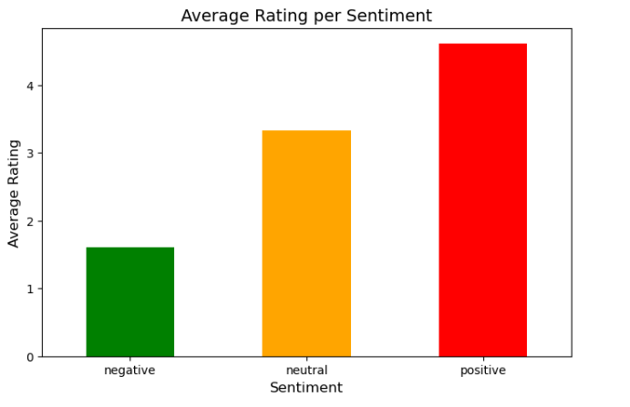

Fig.2 Average rating of the sentiment analysis of Positive, Neutral and Negative values.

* Negative Sentiment reflects an average star rating ranging from 1 to 2 stars, indicating a strong dissatisfaction.
* Neutral Sentiment shows rating hovering around 3 stars, reflecting a moderate or mixed experience.
* Positive sentiment stands out with an average rating between 4 to 5 stars, highlighting strong correlation between positive feedback had high customer satisfaction.
  + - 1. **Word Cloud**

The analysis of sentiment-based word clouds highlights key patterns in word frequency, contextual overlap, and thematic observations. The word *“specified”* is notably prevalent across all three sentiment categories—positive, negative, and neutral. This consistent usage indicates a shared emphasis among customers on precise expectations or product descriptions. It suggests that customers, regardless of their sentiment, value clarity, accuracy, and adherence to promised specifications when evaluating products or services.

Several words, such as *“good,”* appear across both neutral and negative sentiment clouds. This suggests that individual perceptions of product quality and satisfaction are highly subjective and may depend on personal benchmarks or expectations. For instance, while one customer may interpret a product as satisfactory (*“good”*), another may associate the same descriptor with a sense of inadequacy when compared to higher standards. This ambiguity highlights the nuanced nature of customer experiences and underscores the need for granular analysis of product feedback.

**Positive Sentiments:**

The positive sentiment word cloud is characterized by phrases and adjectives that emphasize high levels of satisfaction and perceived value (Fig.3).

**Prominent Phrases**:

Terms such as *“worth every penny,”* *“perfect product,”* *“great product,”* and *“highly recommended”* dominate the positive cloud. These phrases collectively indicate strong approval, with customers expressing that the product meets or exceeds their expectations in terms of quality, performance, and value. Such feedback aligns with existing theories of customer satisfaction, which highlight the importance of delivering value that justifies cost (Kotler & Keller, 2021).

**Adjectives and Descriptions**:

Positive adjectives such as *“classy,”* *“awesome,”* and *“mindblowing”* reveal a high degree of enthusiasm and admiration for the product. These terms suggest not just satisfaction but delight—an emotional response that reflects a strong alignment between customer expectations and product performance.

**Repetition of “Product”**:

The frequent occurrence of the term *“product”* underscores its centrality in positive reviews. This observation suggests that customer satisfaction is closely tied to specific product attributes, including quality, utility, and value-for-money. Customers are likely to emphasize tangible aspects of the product in their positive feedback, as observed in similar studies of consumer behavior (Kotler & Keller, 2021).

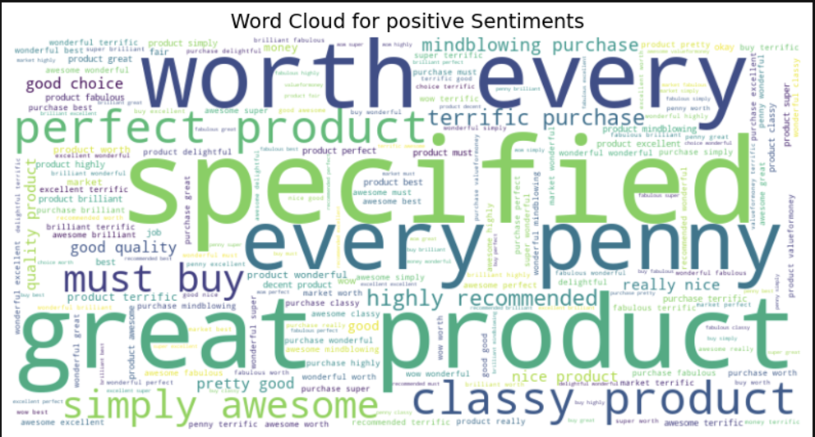

Fig.3 The size of the words represents the frequency of the word mentioned associated with a positive sentiment.

**Negative Sentiments**

The negative sentiment word cloud reveals strong dissatisfaction, often linked to unmet expectations and perceived financial loss (Fig.4).

**Prominent Phrases**:

Words such as *“absolute rubbish,”* *“terrible product,”* *“waste money,”* and *“utterly disappointed”* are frequently observed. These terms reflect intense frustration and disapproval, suggesting significant dissatisfaction with product performance, quality, or durability. This aligns with prior research that indicates strong emotional language is more likely to appear in negative feedback (Kotler & Keller, 2021).

**Themes**:

A recurring theme among negative sentiments is financial dissatisfaction, as evidenced by the repeated use of words like *“money”* and *“waste.”* Customers express frustration regarding unmet value-for-money expectations, which indicates that the perceived cost-benefit ratio of the product did not align with their initial expectations. This supports the notion that perceived financial loss often amplifies negative sentiment (Kotler and Keller, 2021).

**Harsh Adjectives**:

Descriptors such as *“worthless,”* *“horrible,”* and *“useless”* indicate extreme dissatisfaction. These terms not only reflect unmet expectations but also signal a significant gap between the marketed value of the product and its delivered performance. Such language often serves as an emotional outlet for customers to express their disappointment (Chevalier & Mayzlin, 2006).

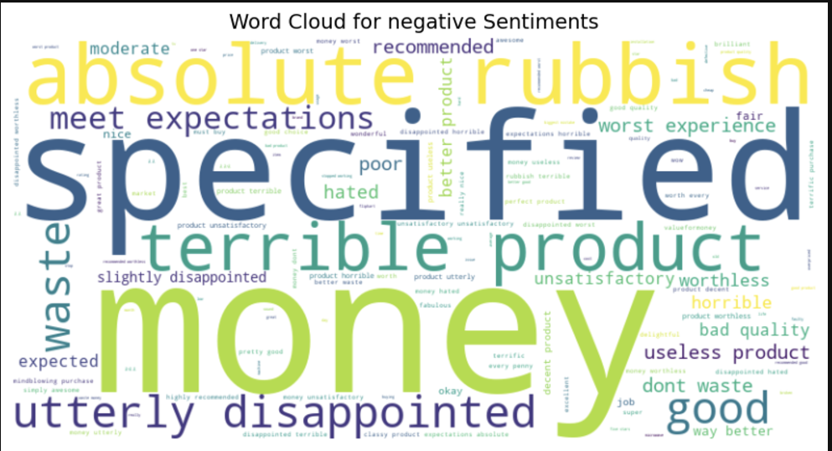

Fig.4 The size of the words represents the frequency of the word mentioned associated with a negative sentiment.

**Neutral Sentiments**

Neutral sentiment feedback is characterized by moderate descriptors and balanced feedback that reflect a lack of strong emotional engagement.

**Prominent Phrases**:

Terms like *“okay,”* *“good,”* *“nice,”* and *“decent product”* dominate the neutral sentiment cloud. These words suggest that while customers did not experience exceptional satisfaction, the product met baseline expectations. The lack of extreme language differentiates this category from both positive and negative sentiments.

**Balanced Feedback**:

The presence of terms such as *“fair”* and *“expected”* indicates that customers perceive the product or service as adequate but not remarkable. This aligns with the concept of customer indifference, where expectations are met without eliciting strong positive or negative reactions (Kotler & Keller, 2021)

**Overlap with Positive and Negative Clouds**:

Words like *“good”,* and *“money”* appear in both the neutral and positive clouds. This overlap suggests an element of ambiguity in customer sentiment. For example, while *“good”* may signify satisfaction in positive contexts, its use in neutral feedback reflects restrained approval.

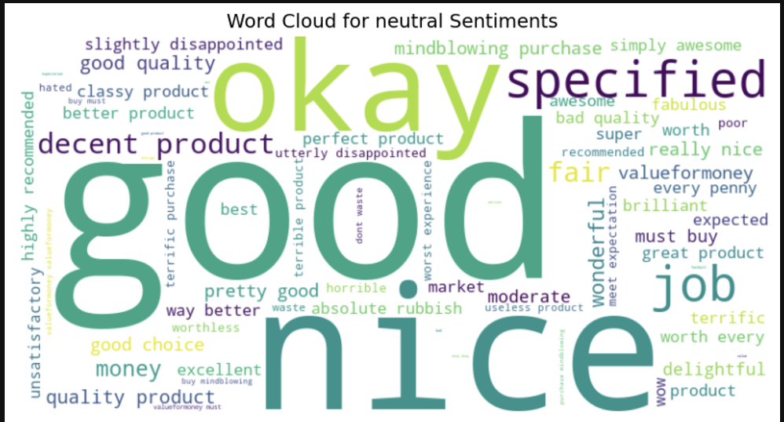

Fig.5 The size of the words represents the frequency of the word mentioned associated with a neutral sentiment.

# Part 4: Research Discussion

## **Discussion**

The predominance of Positive Sentiments with 82% of positive reviews aligns with the industry trend where satisfied customers dominate reviews in successful products and services. This signifies that these products on Flipkart have succeeded in meeting the customer expectations. On the other hand, Negative Sentiments Highlight Critical Gaps with 13% of reviews being negative suggesting the possible areas of improvement which are product defects, delays in delivery. Furthermore, Neutral Feedback is Minimal at less than 5% indicating that the majority of customer form clear opinions about their experiences. Our findings confirm some of these established understandings used on previous studies in e-commerce research highlight the following:

Customer satisfaction is an important indicator that is used to measure customer interest in online shopping (Rahmayanti et al., 2021). The most important factor that influences customer satisfaction is the price and quality of the product. In other words, product quality affects the product’s performance or service, which is closely related to customer value and satisfaction (Choi & Kim, 2013). Moreover, the value for money and delivery issues are common areas of concern in e-commerce platforms that potentially shape consumer behavior and reviews. With the rapid growth of social media corporations, businesses and service managers are more interested in obtaining customer feedback than ever. As a result, sentiment analysis is widely used for product reviews since it provides a comprehensive understanding of customer feedback (Huang et al., 2023).

**Insights About the Research Problem**

* + - 1. **Imbalance Sentiment Distribution**

There is a significant imbalance between positive, negative and neutral sentiments. This problem indicates that dissatisfied or neutral customers might be underrepresented. This could suggest feedback across the spectrum is needed to understand customer experiences better.

* + - 1. **Predominance of Positive Sentiment:**

The analysis revealed that 82% of the reviews were positive, a clear indication that the majority of customers were satisfied with their purchases on Flipkart. This finding is consistent with the broader trend in e-commerce where satisfied customers tend to leave feedback more frequently. The predominance of positive sentiment aligns with existing research on customer satisfaction in e-commerce (Rahmayanti et al., 2021; Choi & Kim, 2013). Positive feedback highlights strong customer approval of product quality, delivery speed, and value for money. This suggests that Flipkart has successfully met customer expectations in these areas, which is crucial for building customer loyalty and retention. Companies in the e-commerce sector can use this insight to reinforce their strengths, such as ensuring product quality and fast delivery, which are essential for maintaining positive customer perceptions.

* + - 1. **Negative Sentiment and Areas for Improvement:**

Although positive sentiment dominated, 13% of reviews were negative, pointing to critical issues such as product defects and delivery delays. These reviews highlight specific pain points that can guide improvements in product quality control and logistics. Negative sentiment often stems from unmet expectations, particularly when products fail to meet advertised standards or when delivery does not occur within the promised time frame. In terms of business strategy, addressing these issues can result in a reduction in negative feedback, leading to better customer retention and improved brand reputation. As businesses become more data-driven, this type of feedback is invaluable for guiding operational changes, ensuring that products and services align with customer expectations.

* + - 1. **Neutral Sentiment:**

Neutral sentiment, comprising less than 5% of the reviews, was the least frequent category. This suggests that the majority of customers were either highly satisfied or dissatisfied, with fewer individuals expressing mixed opinions. Neutral sentiment generally indicates a more balanced or indifferent experience. The scarcity of neutral feedback can be seen as an opportunity for businesses to explore further, as neutral reviews might reveal overlooked aspects of customer experience. For example, customers who express neutral sentiments may have received a product that met some expectations but fell short in other areas. It’s also possible that neutral feedback indicates ambiguity in product quality or delivery, where customers don’t feel strongly enough to give an outright positive or negative rating. This underrepresentation of neutral sentiment could be a sign that businesses are missing valuable input from customers who are neither completely satisfied nor dissatisfied.

* + - 1. **Ratings, Price and Sentiment Correlation:**

The analysis showed a strong correlation between review ratings and sentiment. Negative sentiment is predominantly linked with 1-2 star ratings, indicating dissatisfaction with product quality or service, while positive sentiment is associated with 4-5 star ratings, indicating satisfaction. The findings suggest that pricing plays a crucial role in customer satisfaction. Customers who rate products poorly often mention value-for-money concerns, particularly when the product does not meet expectations. This aligns with previous research that emphasizes the importance of price and product quality in shaping customer satisfaction (Choi & Kim, 2013). By assessing price sensitivity, businesses can better gauge customer expectations and ensure that their products are competitively priced in relation to quality. This insight can help e-commerce companies optimize their product offerings, ensuring that both quality and price align with consumer preferences.

* + - 1. **Key Themes in Sentiment Analysis:**

The analysis identified several recurring themes within the sentiments expressed in the reviews. These include product quality, delivery speed, and customer service. Positive sentiments were frequently tied to quality and pricing, with customers praising products that met or exceeded their expectations in terms of functionality and durability. Negative feedback often highlighted delivery delays and product defects as primary concerns. These recurring themes offer valuable insights into the key drivers of customer satisfaction and dissatisfaction. For businesses, this means that focusing on improving product quality and ensuring timely delivery can have a significant impact on customer perceptions. Addressing these themes in marketing and customer service strategies can lead to enhanced customer satisfaction and improved brand loyalty.

* + - 1. **Cross-Sentiment Observations:**

Interestingly, some words, such as “good” and “money,” appeared across multiple sentiment categories. The word “good,” for example, was found in both positive and neutral sentiment clouds, suggesting that its meaning can vary depending on context. In positive reviews, “good” is often used to praise products, while in neutral feedback, it may be used to describe a product that meets basic expectations but does not exceed them. This cross-sentiment overlap underscores the complexity of sentiment classification and the need for refined sentiment models to capture these nuances. Words like “money” often appear in negative reviews, with customers expressing frustration over perceived value-for-money issues. These observations highlight the need for businesses to pay close attention to the contextual use of language in reviews, as customers may express dissatisfaction in subtle ways that are difficult to detect with simple keyword analysis.

## **Practical Recommendation**

**1. Implement Proactive Customer Service Strategies**

**Recommendation:**

The company should leverage customer feedback to optimize the customer service experience, which means that we need to gain insight into common customer pain points such as payment, product and potential refund issues.

**Measures:**

First, we can implement and improve AI-driven customer support chatbots to provide accurate and quick assistance to instant asked questions. Second, we should increase investment in customer support training to handle complaints related to delays and product defects. Third, we will track customer service performance through Key Performance Indicators (KPIs) such as response time and complaint resolution rate.

**2. Enhance Product Reviews and Rating Systems**

**Recommendation:**

The company should help customers leave more descriptive reviews to enhance data richness for sentiment analysis, which means that we need to encourage more detailed customer feedback on key attributes such as product quality, accuracy of descriptions and overall satisfaction.

**Measures:**

First, we can encourage users to provide more detailed reviews by prompting them with specific and guided questions such as, "How did the product quality meet your expectations?" or "Was the product as described?" Second, we should introduce review incentives including big prizes or discount codes for customers who provide detailed feedback. Third, we can use Python to extract key attributes like price, quality and delivery from updated reviews to generate new reports to identify areas for improvement.

**3. Develop a Data-Driven Pricing Strategy**

**Recommendation:**

The company should dig into the relationship between price, sentiment and ratings to optimize product pricing strategies, which means that we need to identify price points that drive positive customer sentiment and maximize profitability.

**Measures:**

First, we should recalibrate product pricing based on sentiment analysis of different product categories to align prices with customer preferences. Second, we can review pricing data from products with strong positive feedback and identify patterns in price points that correlate with positive customer sentiment. Third, we will utilize dynamic pricing models that adjust based on product demand, customer sentiment and competitor pricing to remain competitive and responsive to market conditions.

**4. Improve Product Delivery and Fulfillment Efficiency**

**Recommendation:**

The company should address common customer grievances related to delayed product delivery, which means that we need to reduce delivery times and improve transparency throughout the order fulfillment process.

**Measures:**

First, we can optimize the logistics network by partnering with local delivery services to reduce last-mile delivery times and speed up order fulfillment. Second, we should increase transparency by offering real-time tracking of orders and sending automated status updates via email, SMS or in-app notifications to keep customers informed. Third, we will conduct post-delivery surveys to gather customer feedback and identify areas for improvement in the fulfillment process.

**5. Concentration on Neutral Comments**

**Recommendation:**

The company should address limitations in sentiment classification of neutral sentiments, which means that we need to improve the accuracy of classifying neutral reviews despite challenges posed by imbalanced data.

**Measures:**

First, we can implement active learning, where the model continuously improves its classification performance based on feedback from human reviewers. Second, we utilize hybrid models that combine lexicon-based and machine learning-based approaches to enhance sentiment classification accuracy. Third, we should fine-tune machine learning models to better classify neutral reviews by leveraging domain-specific data and incorporating additional linguistic features.

**6. Promote Transparent Communication with Customers**

**Recommendation:**

The company should build customer trust and loyalty, which means that we need to provide clear, accessible and accurate information to enhance customer confidence and satisfaction.

**Measures:**

First, we can improve product transparency by providing detailed product descriptions, high-quality images, and video demonstrations to manage customer expectations before purchase. Second, we should launch customer education campaigns through blogs, videos, and social media content that guide customers on how to make the most of Flipkart’s shopping experience, thereby building trust and confidence in the platform.

## **Study Limitations and Recommendations for Future Research**

**Characteristics of Research Process, Design, and Methodology**

This Research utilized sentiment analysis which gives an extensive understanding of customer opinions by categorizing them as positive, neutral, or negative. Sentiment analysis also often struggles to fully capture nuanced emotions or context within customer reviews which has the possibility of potentially impacting the interpretation of the results. The data used for this research was sourced from Flipkart customer reviews. Although it offers valuable insights, it might not represent the opinions of customers who shop on other platforms or non-reviewing customers. This could also limit the generalizability of the findings.

The predominance of positive reviews which amounts to 82% may skew the overall interpretation of customer satisfaction, underestimating the gravity of critical issues raised in the smaller segment of negative reviews. The research targeted important areas of customer experience, but it may have skipped some significant factors like website usability, customer service, or refund processes that influence satisfaction. Relying on quantitative sentiment distribution lacked deeper qualitative insights into specific processes that also influence satisfaction.

**Suggestions for Future Research**

In conducting future research, we have come up with some suggestions which include expanding our data source. In terms of execution, we would incorporate reviews from multiple e-commerce platforms and include social media mentions or surveys to enhance the diversity of customer feedback. We would also consider conducting a qualitative analysis to complement the sentiment analysis using a thematic analysis of reviews. This will help us to better understand nuanced customer concerns and preferences. Designing studies to actively gather feedback from neutral and dissatisfied customers will be done to address sentiment imbalance. This will be done through targeted surveys or focus groups, to ensure a balanced representation of sentiments.

Besides, we will incorporate additional variables by examining the impact of other factors like customer service, website usability or refund policies on overall satisfaction. We would also track sentiment trends over time to determine how product quality, delivery or value for money have improved and how they may affect customer satisfaction in the long run. Lastly leveraging advanced AI tools will help to better capture nuanced feedback and provide actionable insights into the root cause of customer sentiments.

## **Conclusion**

**Main Points of Evidence:**

**1. Sentiment Distribution:**

* Positive reviews (82%) indicate high customer satisfaction, aligning with industry trends where satisfied customers are more vocal in leaving feedback.
* Negative reviews (13%) focus on product defects and delivery delays, offering clear areas for improvement.
* Neutral sentiment (less than 5%) is minimal, signaling that most customers have strong opinions (either positive or negative).

**2. Correlation Between Price, Rating, and Sentiment:**

* High ratings (4-5 stars) correlate with positive sentiment, indicating satisfaction with product quality, delivery, and value for money.
* Low ratings (1-2 stars) correlate with negative sentiment, highlighting dissatisfaction with product defects and delays.

**3. Key Themes in Customer Feedback:**

* Positive sentiment is linked to quality products, efficient delivery, and good customer service.
* Negative sentiment often reflects issues with product defects and delays, providing actionable feedback for improvements.

**4. Imbalance in Sentiment Distribution:**

* The distribution skews heavily toward positive feedback, potentially underrepresenting neutral or dissatisfied customers. This imbalance suggests a need for better systems to capture a fuller range of customer experiences.

**5. Contextual Overlap in Sentiment:**

* Words like “good” and “money” appeared in both positive and negative reviews, underlining the importance of understanding the context behind customer feedback for more accurate sentiment analysis.

**Why the Research Matters to Your Client and Readers:**

This research provides actionable insights for businesses, particularly e-commerce platforms like Flipkart, to enhance customer satisfaction. Understanding the primary drivers of positive and negative sentiment allows companies to make data-driven decisions to improve their product offerings, delivery systems, and customer service. By addressing common pain points such as product defects and delivery delays, businesses can improve customer retention and minimize negative feedback.

Moreover, the research identifies the need for a more balanced approach to capturing feedback, ensuring that both satisfied and dissatisfied customers are heard. This can help businesses identify gaps in their offerings and make adjustments that cater to a broader customer base.

For readers, especially stakeholders in e-commerce businesses, the findings underscore the importance of sentiment analysis in understanding consumer behavior. By using these insights, businesses can refine their marketing strategies, customer engagement efforts, and product development to meet customer expectations more effectively. This research, therefore, not only highlights current satisfaction levels but also points to areas where improvements can be made to create better customer experiences and drive long-term success.

## 

## **References**

[Balaji, K., & Seshagiri Rao, P. (2023). Unraveling success: A case study on Flipkart’s e-commerce journey. In D. Sharma & R. Pravinbhai (Eds.), Advancements in commerce, economics & management: A research compilation (pp. 43-49). Infinity.](https://www.zotero.org/google-docs/?Ackr6v)

Choi, E. J., & Kim, S. H. (2013). The study of the impact of perceived quality and value of social enterprises on customer satisfaction and re-purchase intention. International Journal of Smart Home, 7(1), 239–252.

Dalal, M. (2016, May 25). *Flipkart finally seems to have a blueprint for its business model.* *Mint.*<https://www.livemint.com/Companies/kcNbpF89GYRnGbKHrWqG1H/Flipkart-finally-seems-to-have-a-blueprint-of-its-business-m.html>

[Fisher, N. I., & Kordupleski, R. E. (2019). Good and bad market research: A critical review of Net Promoter Score. Applied Stochastic Models in Business and Industry, 35(1), 138-151.](https://www.zotero.org/google-docs/?Ackr6v) <https://doi.org/10.1002/asmb.2417>

Gu, T., Xu, G., & Luo, J. (2020). Sentiment Analysis via Deep Multichannel Neural Networks Huang, H., Asemi, A., & Mustafa, M. B. (2023). Sentiment Analysis in E-commerce Platforms: A Review of Current Techniques and Future Directions. *IEEE Access*, *11*, 1-1. <https://doi.org/10.1109/ACCESS.2023.3307308>

Kotler, P., & Keller, K. L. (2021). Marketing management. 16th edition. *New Jersey*, USA.

[Kumar, A., Gupta, S., Sahu, A., & Kant, M. (2022). Deriving Customer Experience Implicitly from Social Media. Companion Proceedings of the Web Conference 2022](https://www.zotero.org/google-docs/?Ackr6v), 131-135. https://doi.org/10.1145/3487553.3524219

Pitchiah, V. (2016, August 22). *Sachin Bansal had to step down as CEO after Flipkart missed targets.* *Techcircle.* <https://www.techcircle.in/2016/08/22/sachin-bansal-had-to-step-down-as-ceo-after-flipkart-missed-targets>

Rahmayanti, D., Wirdianto, E., Arief, I., Zahra, A. F., & Ahmad, H. (2021). Factors Affecting Customer Satisfaction In E-Commerce. *Jurnal Ilmiah Teknik Industri*, *20*(2), 164-172. <https://doi.org/10.23917/jiti.v20i2.15635>

[Rajan, T. (2020). The Flipkart Story in India: From the Start to Walmart. Asian Journal of Management Cases](https://www.zotero.org/google-docs/?Ackr6v). https://doi.org/10.1177/0972820120914526

[Sakhare, N., Verma, D., Kolekar, V., Shelke, A., Dixit, A., & Meshram, N. (2023). E-commerce Product Price Monitoring and Comparison using Sentiment Analysis. International Journal on Recent and Innovation Trends in Computing and Communication, 11](https://www.zotero.org/google-docs/?Ackr6v)(5), 404-411. https://doi.org/10.17762/ijritcc.v11i5.6693

Vijayaragavan, P., Suresh, C., Maheshwari, A. et al. Sustainable sentiment analysis on E-commerce platforms using a weighted parallel hybrid deep learning approach for smart cities applications. Sci Rep 14, 26508 (2024).[*https://doi.org/10.1038/s41598-024-78318-1*](https://doi.org/10.1038/s41598-024-78318-1)

[Sugant, R. (2020). Net promoter score-an evaluation of top companies in online retailing in India. SAMVAD, 20, 14-27.](https://www.zotero.org/google-docs/?Ackr6v)

Taneja, K., Vashishtha, J.,& Ratnoo, S. (2024). Transformer Based Unsupervised Learning Approach for Imbalanced Text Sentiment Analysis of E-Commerce Reviews. *Procedia Computer Science*, 235 (2024), 2318–2331. <https://doi.org/10.1016/j.procs.2024.04.220>

Vijayaragavan, P., Suresh, C., Maheshwari, A., Vijayalakshmi, K., Narayanamoorthi, R., Gono, M., & Novak, T. (2024). Sustainable sentiment analysis on E-commerce platforms using. A weighted parallel hybrid deep learning approach for smart cities applications. *Scientific Reports*. 14. <https://doi.org/10.1038/s41598-024-78318-1>